5G

⚡ What Is 5G (Fifth Generation Mobile Network)?
# Source: AI Source: Provided by: [Data Path: Persons Table -> ID Column: 1, Name_En Column: Motasem Essam] -> From: [ChatGPT] on [1/23/2026]
5G is the fifth generation of mobile network technology, designed to deliver blazing-fast speeds, ultra-low latency, and massive device connectivity. It powers not just smartphones, but also smart cities, autonomous cars, industrial automation, and the Internet of Things (IoT).
📡 5G is more than just faster — it’s a new wireless platform built for the future of connected everything.

🚀 Key Features of 5G:
# Source: AI Source: Provided by: [Data Path: Persons Table -> ID Column: 1, Name_En Column: Motasem Essam] -> From: [ChatGPT] on [1/23/2026]
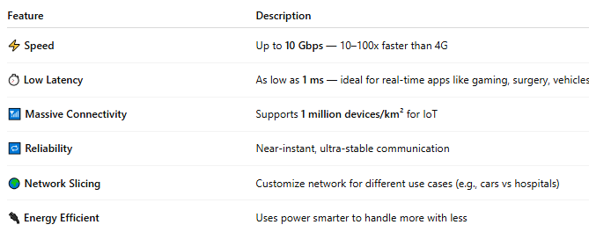

Feature | Description
⚡ Speed | Up to 10 Gbps — 10–100x faster than 4G
⏱️ Low Latency | As low as 1 ms — ideal for real-time apps like gaming, surgery, vehicles
📶 Massive Connectivity | Supports 1 million devices/km² for IoT
🔁 Reliability | Near-instant, ultra-stable communication
🌍 Network Slicing | Customize network for different use cases (e.g., cars vs hospitals)
🔌 Energy Efficient | Uses power smarter to handle more with less

🧠 Core 5G Technologies:
# Source: AI Source: Provided by: [Data Path: Persons Table -> ID Column: 1, Name_En Column: Motasem Essam] -> From: [ChatGPT] on [1/23/2026]
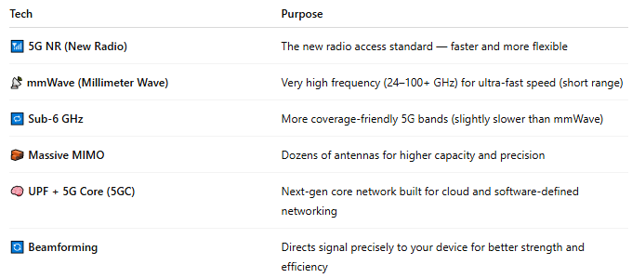

Tech | Purpose
📶 5G NR (New Radio) | The new radio access standard — faster and more flexible
📡 mmWave (Millimeter Wave) | Very high frequency (24–100+ GHz) for ultra-fast speed (short range)
🔁 Sub-6 GHz | More coverage-friendly 5G bands (slightly slower than mmWave)
🧱 Massive MIMO | Dozens of antennas for higher capacity and precision
🧠 UPF + 5G Core (5GC) | Next-gen core network built for cloud and software-defined networking
🔄 Beamforming | Directs signal precisely to your device for better strength and efficiency

📊 5G Speed & Latency Comparison:
# Source: AI Source: Provided by: [Data Path: Persons Table -> ID Column: 1, Name_En Column: Motasem Essam] -> From: [ChatGPT] on [1/23/2026]
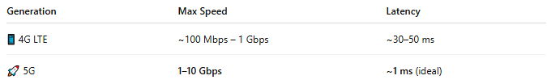

Generation | Max Speed | Latency
📱 4G LTE | ~100 Mbps – 1 Gbps | ~30–50 ms
🚀 5G | 1–10 Gbps | ~1 ms (ideal)

🌍 Use Cases of 5G:
# Source: AI Source: Provided by: [Data Path: Persons Table -> ID Column: 1, Name_En Column: Motasem Essam] -> From: [ChatGPT] on [1/23/2026]
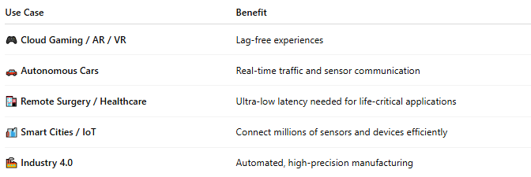

Use Case | Benefit
🎮 Cloud Gaming / AR / VR | Lag-free experiences
🚗 Autonomous Cars | Real-time traffic and sensor communication
🏥 Remote Surgery / Healthcare | Ultra-low latency needed for life-critical applications
🏙️ Smart Cities / IoT | Connect millions of sensors and devices efficiently
🏭 Industry 4.0 | Automated, high-precision manufacturing

📱 Types of 5G Deployment:
# Source: AI Source: Provided by: [Data Path: Persons Table -> ID Column: 1, Name_En Column: Motasem Essam] -> From: [ChatGPT] on [1/23/2026]
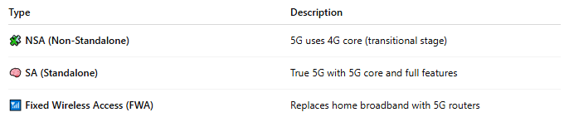

Type | Description
🧩 NSA (Non-Standalone) | 5G uses 4G core (transitional stage)
🧠 SA (Standalone) | True 5G with 5G core and full features
📶 Fixed Wireless Access (FWA) | Replaces home broadband with 5G routers

📉 Challenges of 5G:
# Source: AI Source: Provided by: [Data Path: Persons Table -> ID Column: 1, Name_En Column: Motasem Essam] -> From: [ChatGPT] on [1/23/2026]
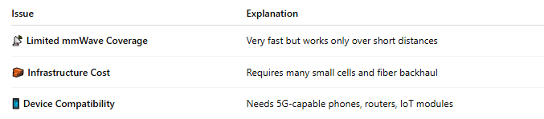

Issue | Explanation
📡 Limited mmWave Coverage | Very fast but works only over short distances
🧱 Infrastructure Cost | Requires many small cells and fiber backhaul
📱 Device Compatibility | Needs 5G-capable phones, routers, IoT modules

📖 Summary:
# Source: AI Source: Provided by: [Data Path: Persons Table -> ID Column: 1, Name_En Column: Motasem Essam] -> From: [ChatGPT] on [1/23/2026]
5G is the next step in mobile evolution that delivers:
- 🚀 Speed: Up to 10 Gbps
- ⏱️ Latency: Near-zero delay
- 🌐 Massive capacity for devices and data
- 🤖 Powering the future: smart cars, cities, and industries
It’s not just faster — it’s smarter, more flexible, and built for everything beyond smartphones.

